Golden Spiral
# Source: AI Source: Provided by: [Data Path: Persons Table -> ID Column: 1, Name_En Column: Motasem Essam] -> From: [ChatGPT] on [7/25/2026]
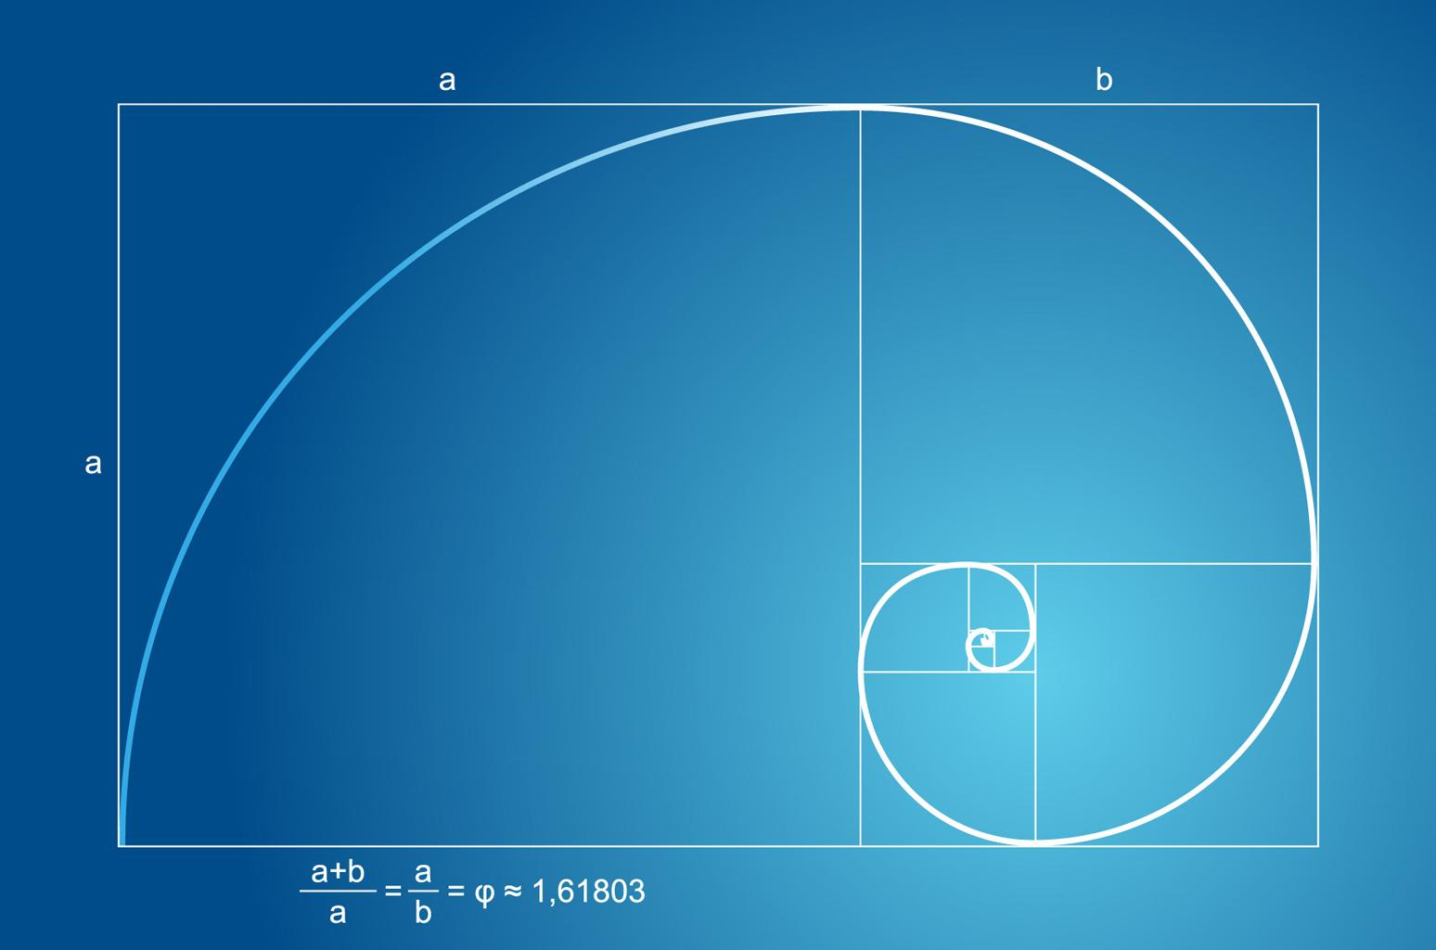
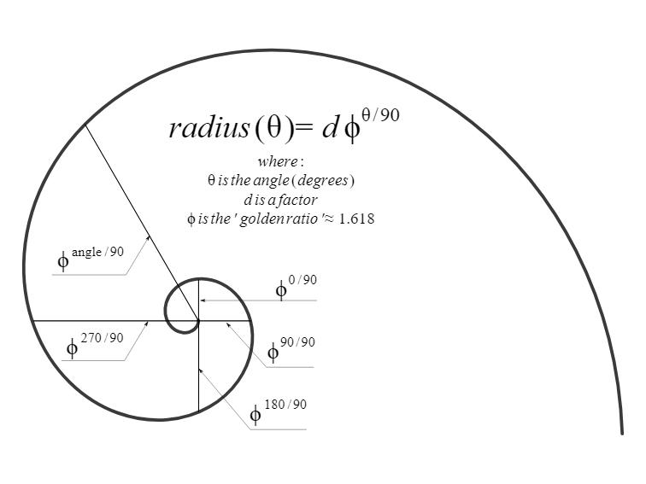
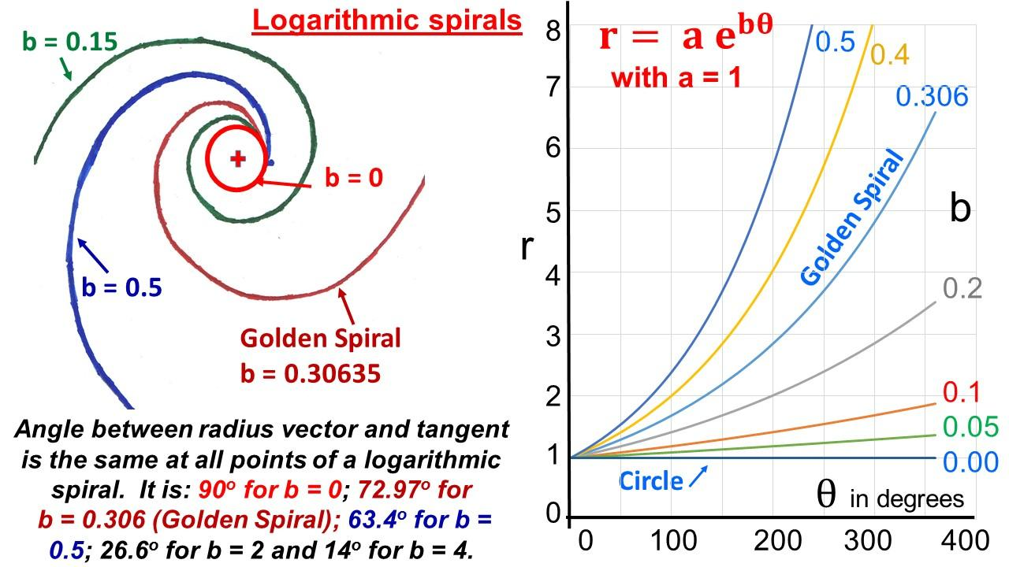
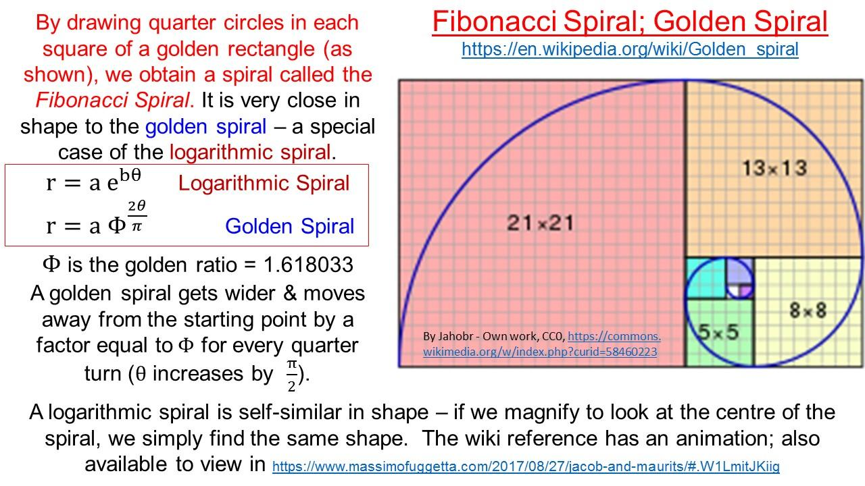
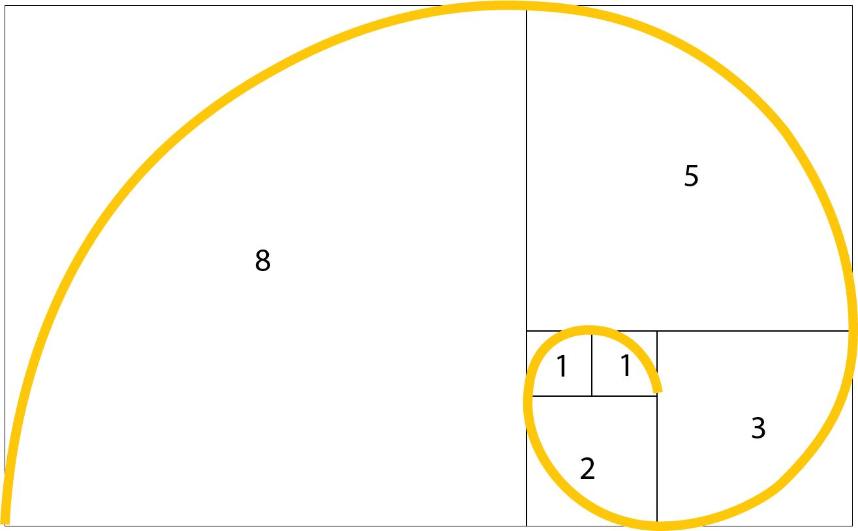

Definition
# Source: AI Source: Provided by: [Data Path: Persons Table -> ID Column: 1, Name_En Column: Motasem Essam] -> From: [ChatGPT] on [7/25/2026]
A Golden Spiral is a particular logarithmic spiral whose radius increases by a factor of the Golden Ratio $ϕ$for every quarter turn (${90}^{∘}$).
The Golden Ratio is:
$$\boxed{ϕ=\frac{1+\sqrt{5}}{2}≈1.618}$$
A logarithmic spiral has the general form:
$$r=ae^{bθ}$$
For a Golden Spiral, the constant $b$is chosen so that:
$$\boxed{r\left(θ+\frac{π}{2}\right)=ϕ r\left(θ\right)}$$
Thus, the Golden Spiral is not a separate fundamental spiral family; it is a special logarithmic spiral.

Fundamental Concept
# Source: AI Source: Provided by: [Data Path: Persons Table -> ID Column: 1, Name_En Column: Motasem Essam] -> From: [ChatGPT] on [7/25/2026]
The defining property is the constant growth ratio:
$$\boxed{\frac{r\left(θ+π/2\right)}{r\left(θ\right)}=ϕ}$$
where:
$$\boxed{ϕ=\frac{1+\sqrt{5}}{2}}$$
Therefore, every ${90}^{∘}$rotation multiplies the radius by approximately $1.618$.
For example, if:
$$r_{0}=1$$
then after successive quarter turns:
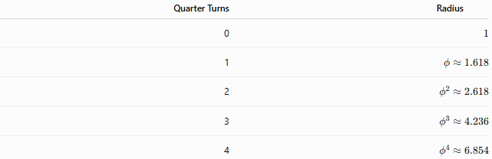
Quarter Turns | Radius
0 | $$1$$
1 | $$ϕ≈1.618$$
2 | $$ϕ^{2}≈2.618$$
3 | $$ϕ^{3}≈4.236$$
4 | $$ϕ^{4}≈6.854$$
Thus:
$$\boxed{r_{n}=r_{0}ϕ^{n}}$$

Basic Structure
# Source: AI Source: Provided by: [Data Path: Persons Table -> ID Column: 1, Name_En Column: Motasem Essam] -> From: [ChatGPT] on [7/25/2026]
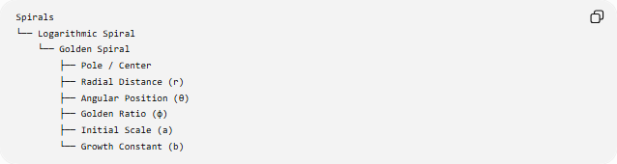
Spirals
└── Logarithmic Spiral
└── Golden Spiral
├── Pole / Center
├── Radial Distance (r)
├── Angular Position (θ)
├── Golden Ratio (φ)
├── Initial Scale (a)
└── Growth Constant (b)
The Golden Spiral inherits the fundamental properties of the logarithmic spiral.

Golden Ratio
# Source: AI Source: Provided by: [Data Path: Persons Table -> ID Column: 1, Name_En Column: Motasem Essam] -> From: [ChatGPT] on [7/25/2026]
The Golden Ratio is:
$$\boxed{ϕ=\frac{1+\sqrt{5}}{2}}$$
with the important identities:
$$\boxed{ϕ^{2}=ϕ+1}$$
and:
$$\boxed{\frac{1}{ϕ}=ϕ-1}$$
Numerically:
$$ϕ≈1.6180339887$$
The Golden Spiral uses this number as its characteristic growth factor.

Standard Mathematical Representation
# Source: AI Source: Provided by: [Data Path: Persons Table -> ID Column: 1, Name_En Column: Motasem Essam] -> From: [ChatGPT] on [7/25/2026]
A logarithmic spiral is:
$$r=ae^{bθ}$$
For the Golden Spiral, require:
$$r\left(θ+\frac{π}{2}\right)=ϕr\left(θ\right)$$
Substituting:
$$ae^{b\left(θ+π/2\right)}=ϕae^{bθ}$$
Therefore:
$$e^{bπ/2}=ϕ$$
Taking the natural logarithm:
$$\frac{bπ}{2}=\ln{ϕ}$$
so:
$$\boxed{b=\frac{2\ln{ϕ}}{π}}$$
Therefore, a standard mathematical model is:
$$\boxed{r=ae^{\left(\frac{2\ln{ϕ}}{π}\right)θ}}$$
where $a>0$.

Parametric Form
# Source: AI Source: Provided by: [Data Path: Persons Table -> ID Column: 1, Name_En Column: Motasem Essam] -> From: [ChatGPT] on [7/25/2026]
Using:
$$x=r\cos{θ}$$
and:
$$y=r\sin{θ}$$
the Golden Spiral can be represented parametrically as:
$$\boxed{x=ae^{\left(\frac{2\ln{ϕ}}{π}\right)θ}\cos{θ}} \\ \boxed{y=ae^{\left(\frac{2\ln{ϕ}}{π}\right)θ}\sin{θ}}$$

Radial Growth
# Source: AI Source: Provided by: [Data Path: Persons Table -> ID Column: 1, Name_En Column: Motasem Essam] -> From: [ChatGPT] on [7/25/2026]
For the logarithmic spiral:
$$r=ae^{bθ}$$
we have:
$$\frac{dr}{dθ}=br$$
For the Golden Spiral:
$$\boxed{\frac{dr}{dθ}=\frac{2\ln{ϕ}}{π}r}$$
Thus, the rate of radial growth is proportional to the current radius.
As the spiral becomes larger, its absolute radial growth becomes larger as well.

Growth Over Different Angles
# Source: AI Source: Provided by: [Data Path: Persons Table -> ID Column: 1, Name_En Column: Motasem Essam] -> From: [ChatGPT] on [7/25/2026]
The Golden Spiral is characterized by growth by $ϕ$over ${90}^{∘}$:
$$\boxed{r\left(θ+\frac{π}{2}\right)=ϕr\left(θ\right)}$$
After ${180}^{∘}$:
$$r\left(θ+π\right)=ϕ^{2}r\left(θ\right)$$
After ${270}^{∘}$:
$$r\left(θ+\frac{3π}{2}\right)=ϕ^{3}r\left(θ\right)$$
After a complete revolution:
$$r\left(θ+2π\right)=ϕ^{4}r\left(θ\right)$$
Since:
$$ϕ^{4}≈6.854$$
the radius is approximately $6.854$times larger after one complete revolution.

Equiangular Property
# Source: AI Source: Provided by: [Data Path: Persons Table -> ID Column: 1, Name_En Column: Motasem Essam] -> From: [ChatGPT] on [7/25/2026]
Like every logarithmic spiral, the Golden Spiral is equiangular.
This means that the angle between the tangent to the spiral and the radial line from the pole is constant.
For:
$$r=ae^{bθ}$$
the angle $α$satisfies:
$$\boxed{\tan{α}=\frac{1}{b}}$$
For the Golden Spiral:
$$b=\frac{2\ln{ϕ}}{π}$$
so:
$$\boxed{\tan{α}=\frac{π}{2\ln{ϕ}}}$$
Thus, the tangent intersects radial lines at a constant angle.

Polar Area
# Source: AI Source: Provided by: [Data Path: Persons Table -> ID Column: 1, Name_En Column: Motasem Essam] -> From: [ChatGPT] on [7/25/2026]
For a polar curve:
$$A=\frac{1}{2}\int_{θ_{1}}^{θ_{2}}{r^{2}} dθ$$
For the Golden Spiral:
$$r=ae^{bθ}$$
where:
$$b=\frac{2\ln{ϕ}}{π}$$
Therefore:
$$A=\frac{1}{2}a^{2}\int_{θ_{1}}^{θ_{2}}{e^{2bθ}} dθ$$
giving:
$$\boxed{A=\frac{a^{2}}{4b}\left(e^{2bθ_{2}}-e^{2bθ_{1}}\right)}$$
for $b≠0$.

Arc Length
# Source: AI Source: Provided by: [Data Path: Persons Table -> ID Column: 1, Name_En Column: Motasem Essam] -> From: [ChatGPT] on [7/25/2026]
The polar arc-length formula is:
$$L=\int_{θ_{1}}^{θ_{2}}{\sqrt{r^{2}+{\left(\frac{dr}{dθ}\right)}^{2}}} dθ$$
Since:
$$\frac{dr}{dθ}=br$$
we obtain:
$$L=\int_{θ_{1}}^{θ_{2}}{r}\sqrt{1+b^{2}} dθ$$
For:
$$r=ae^{bθ}$$
this becomes:
$$\boxed{L=\frac{a\sqrt{1+b^{2}}}{b}\left(e^{bθ_{2}}-e^{bθ_{1}}\right)}$$
for $b>0$.

Golden Spiral and the Golden Rectangle
# Source: AI Source: Provided by: [Data Path: Persons Table -> ID Column: 1, Name_En Column: Motasem Essam] -> From: [ChatGPT] on [7/25/2026]
A common geometric construction connects the Golden Spiral with a sequence of Golden Rectangles.
A Golden Rectangle has side lengths satisfying:
$$\boxed{\frac{\text{long side}}{\text{short side}}=ϕ}$$
When a square is repeatedly removed from a Golden Rectangle, the remaining rectangles maintain the same aspect ratio.
Quarter-circle arcs can then be drawn inside the successive squares to create a Golden-Ratio-based spiral approximation.
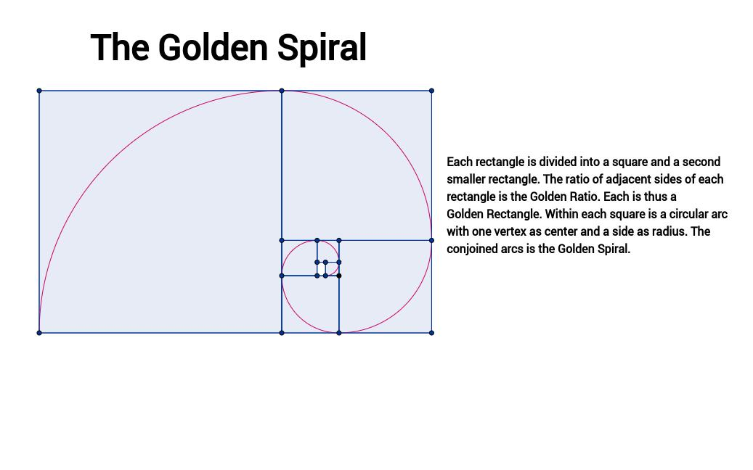
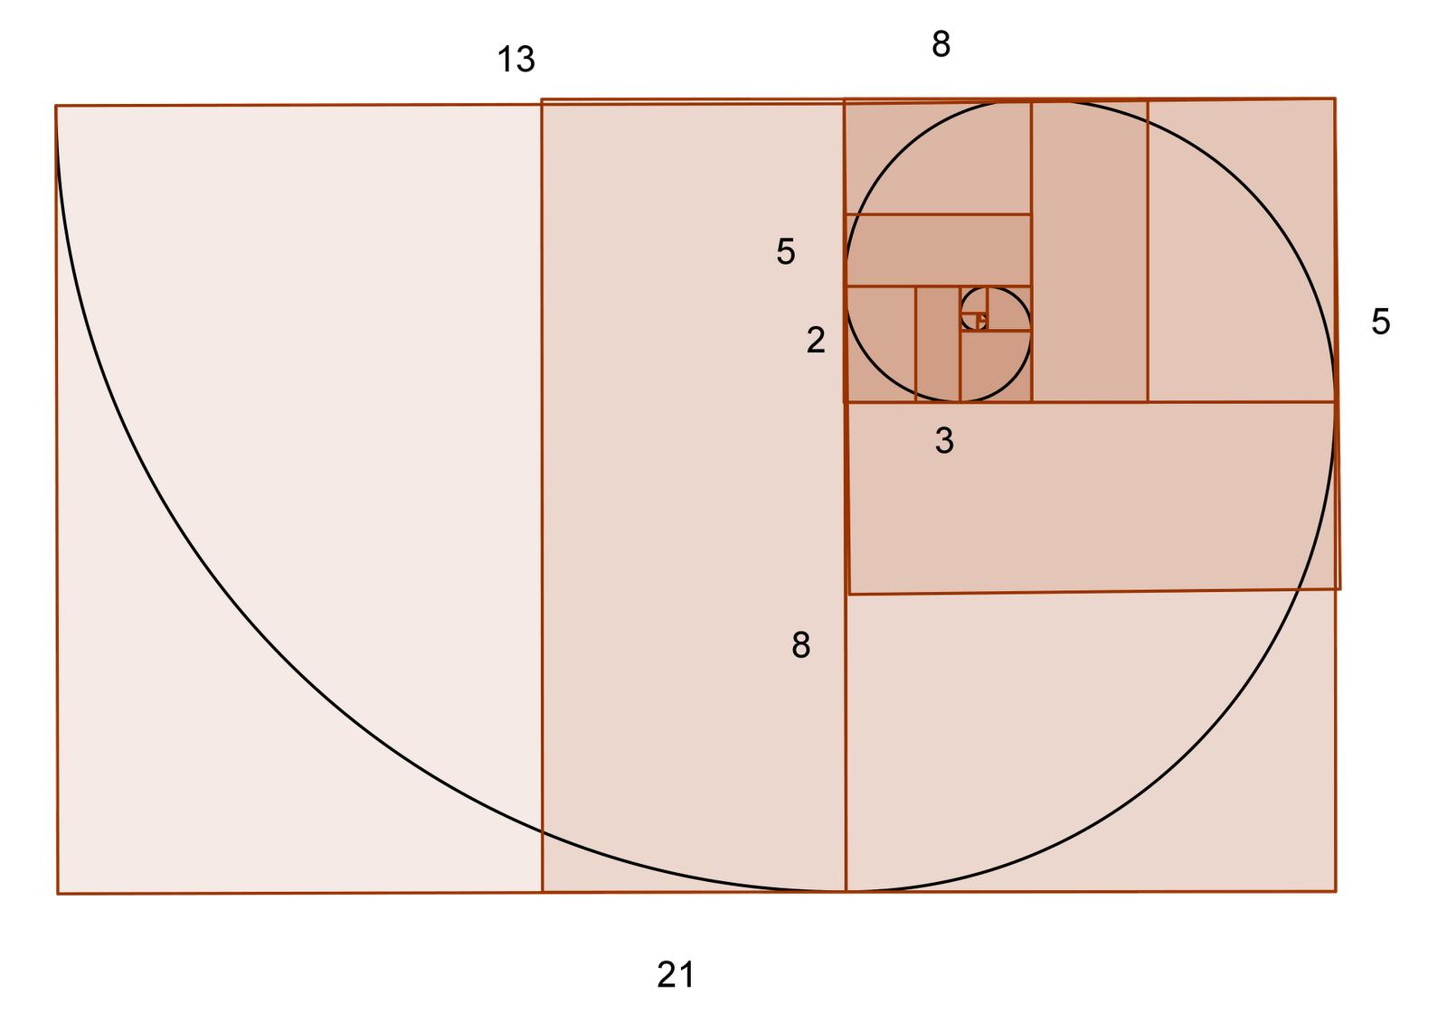
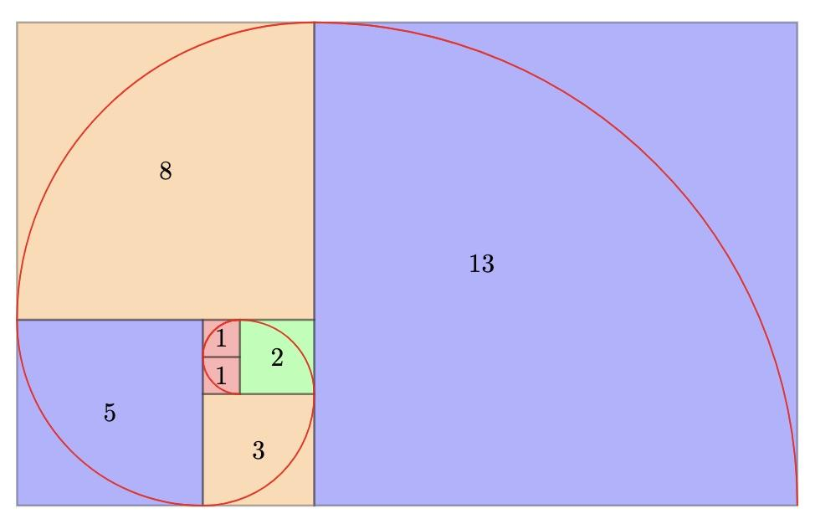
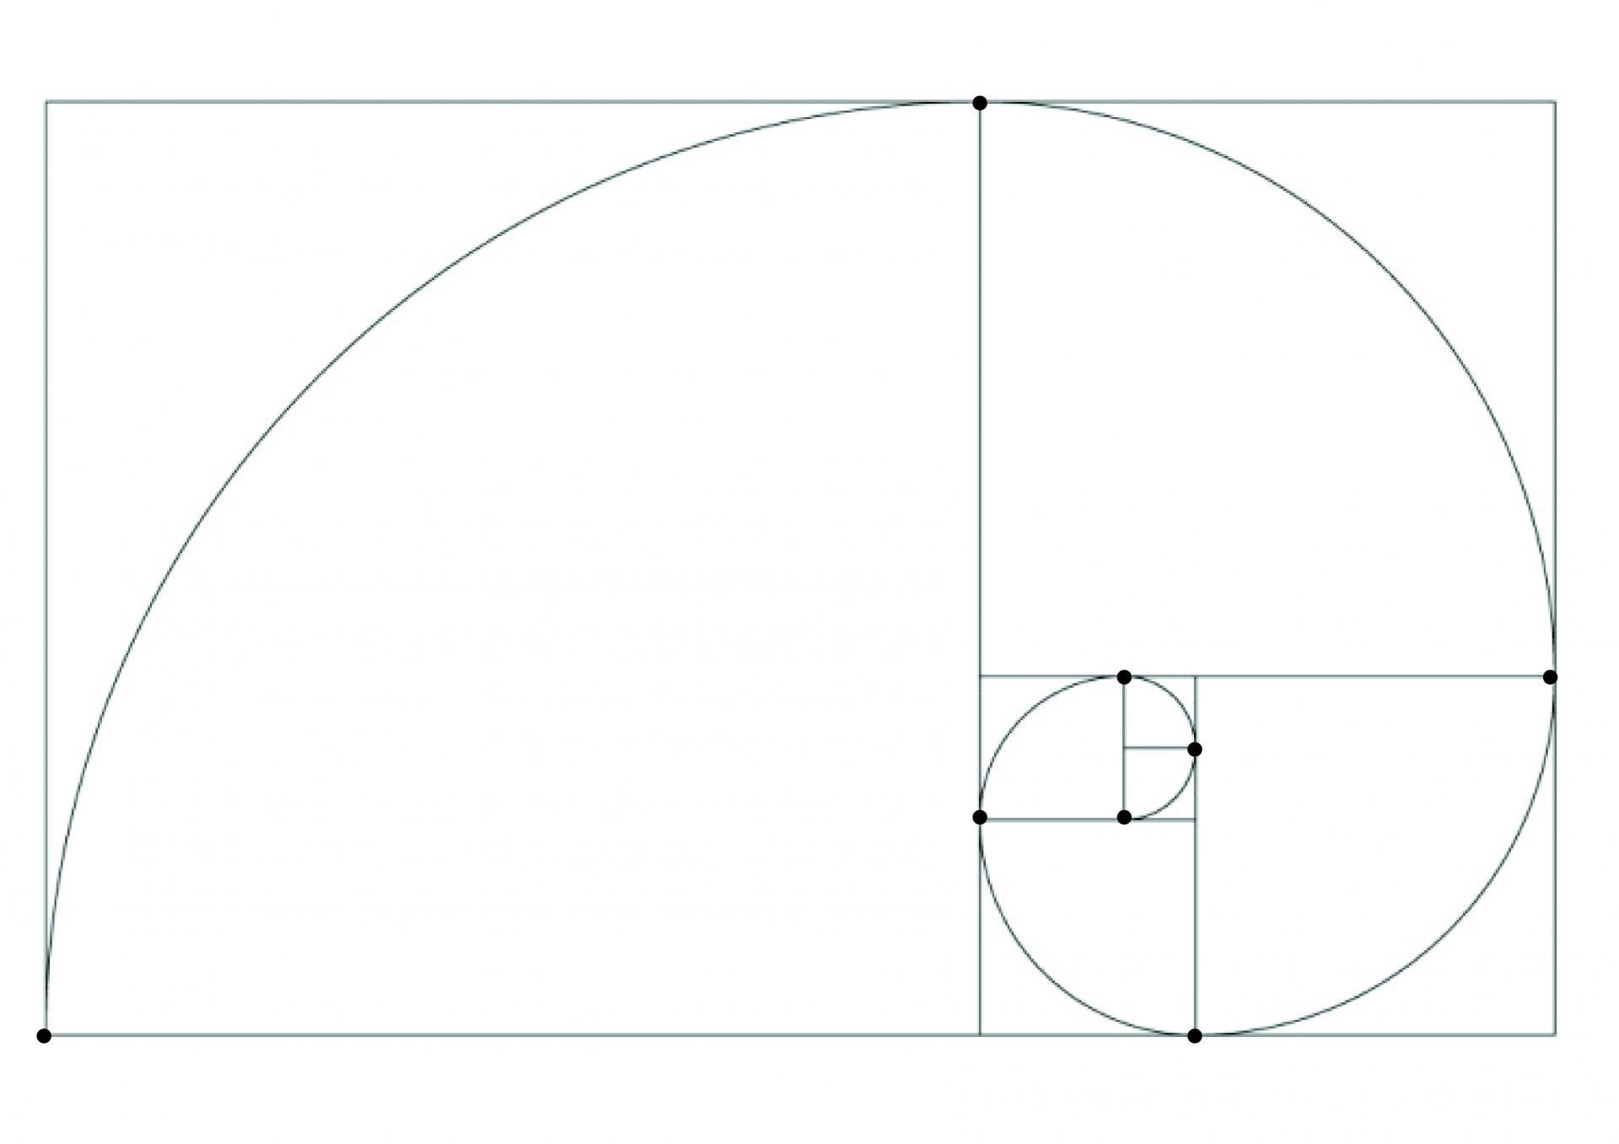
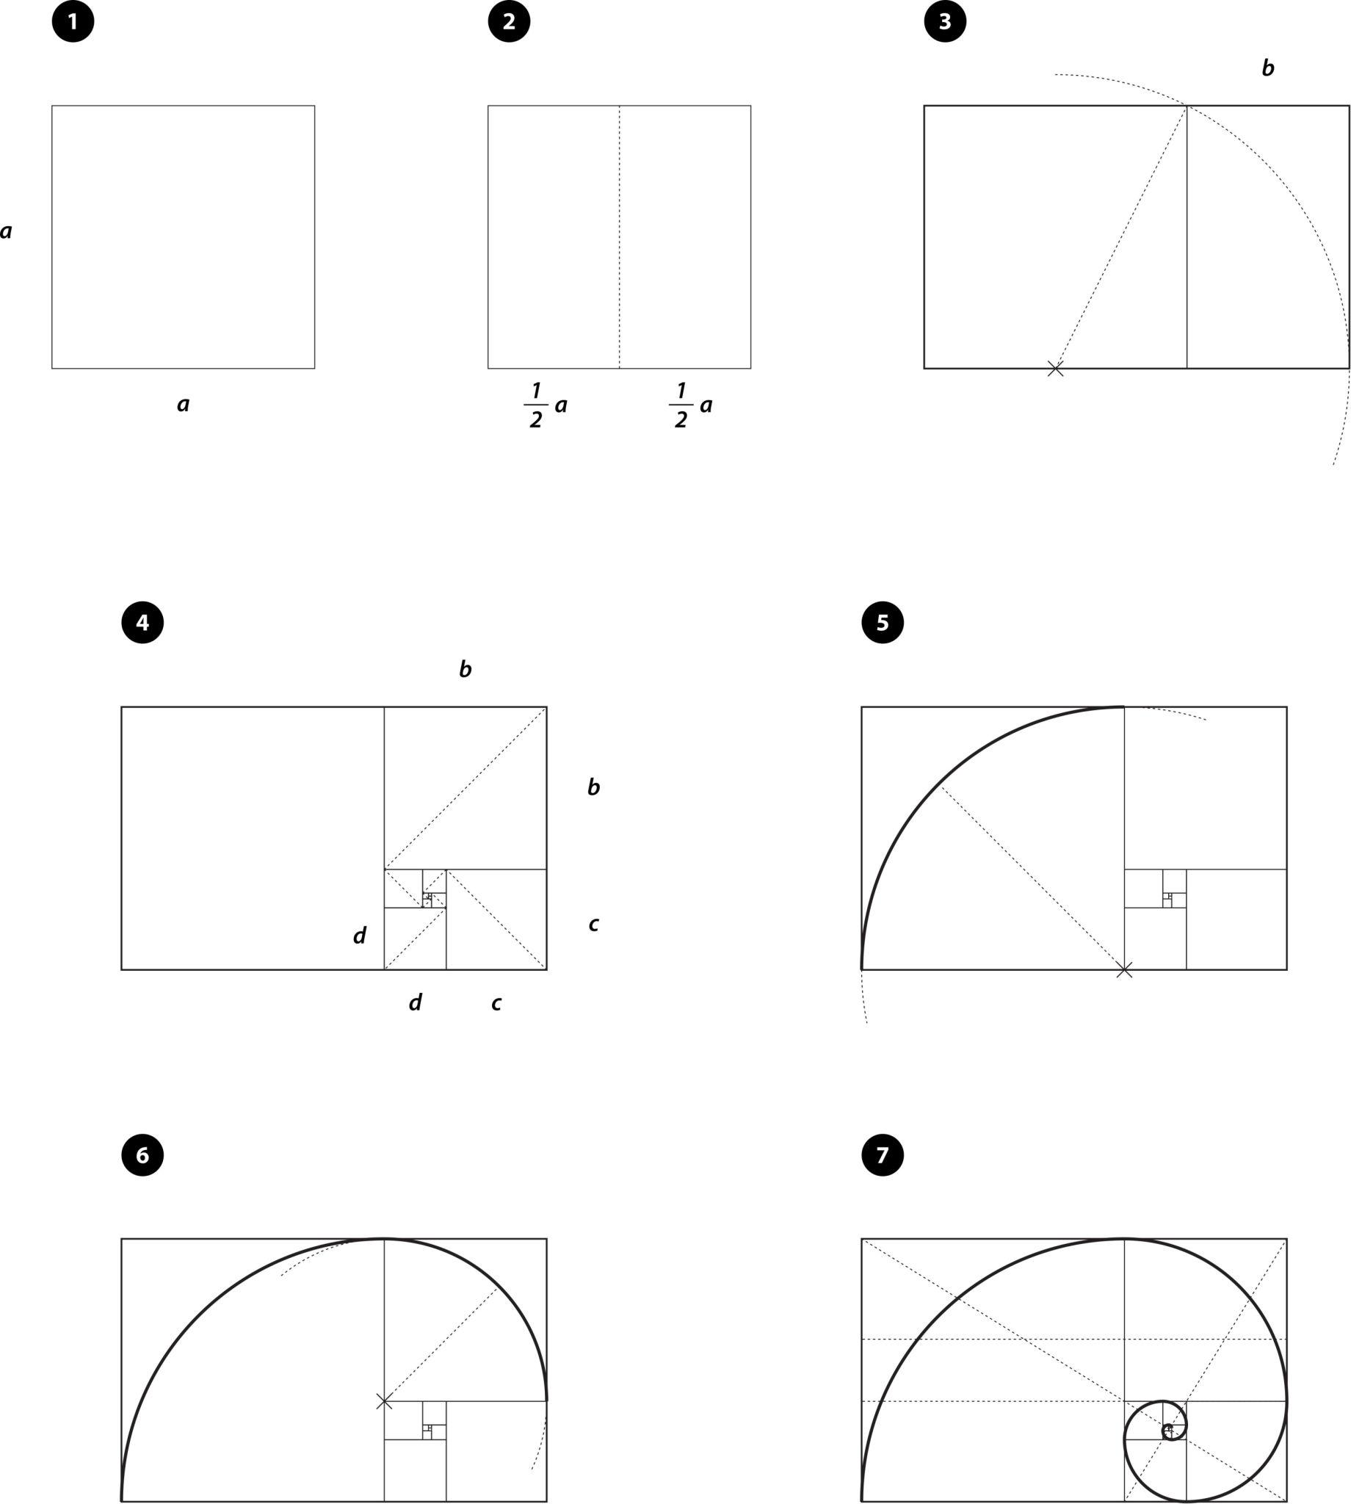
Important distinction
The commonly drawn spiral made from quarter-circles inside successive Golden-Ratio squares is an approximation to a true logarithmic Golden Spiral.
The exact mathematical Golden Spiral is:
$$\boxed{r=ae^{\left(2\ln{ϕ}/π\right)θ}}$$

Golden Spiral vs Golden Ratio
# Source: AI Source: Provided by: [Data Path: Persons Table -> ID Column: 1, Name_En Column: Motasem Essam] -> From: [ChatGPT] on [7/25/2026]
These concepts are related but are not identical.
Golden Ratio
A number:
$$\boxed{ϕ=\frac{1+\sqrt{5}}{2}}$$
Golden Rectangle
A rectangle whose side ratio is:
$$\boxed{ϕ}$$
Golden Spiral
A logarithmic spiral whose radius grows by:
$$\boxed{ϕ}$$
for every quarter turn.
Therefore:
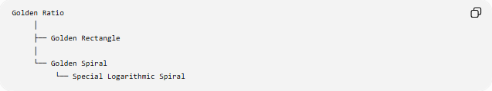
Golden Ratio
│
├── Golden Rectangle
│
└── Golden Spiral
└── Special Logarithmic Spiral

Golden Spiral vs Logarithmic Spiral
# Source: AI Source: Provided by: [Data Path: Persons Table -> ID Column: 1, Name_En Column: Motasem Essam] -> From: [ChatGPT] on [7/25/2026]
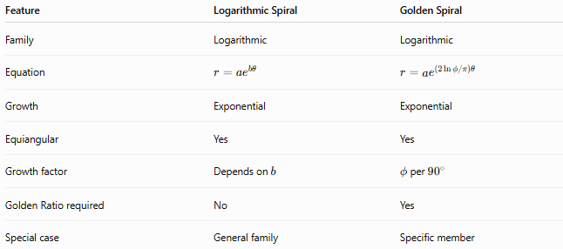
Feature | Logarithmic Spiral | Golden Spiral
Family | Logarithmic | Logarithmic
Equation | $$r=ae^{bθ}$$ | $$r=ae^{\left(2\ln{ϕ}/π\right)θ}$$
Growth | Exponential | Exponential
Equiangular | Yes | Yes
Growth factor | Depends on $b$ | $ϕ$per ${90}^{∘}$
Golden Ratio required | No | Yes
Special case | General family | Specific member
Therefore:
$$\boxed{\text{Golden Spiral}⊂\text{Logarithmic Spirals}}$$

Golden Spiral vs Archimedean Spiral
# Source: AI Source: Provided by: [Data Path: Persons Table -> ID Column: 1, Name_En Column: Motasem Essam] -> From: [ChatGPT] on [7/25/2026]
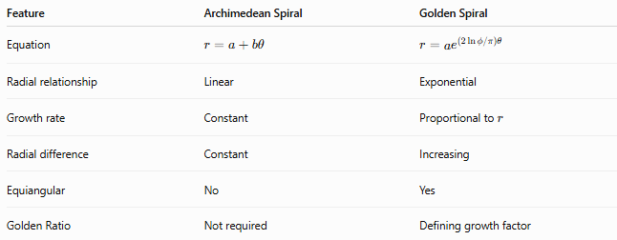
Feature | Archimedean Spiral | Golden Spiral
Equation | $$r=a+bθ$$ | $$r=ae^{\left(2\ln{ϕ}/π\right)θ}$$
Radial relationship | Linear | Exponential
Growth rate | Constant | Proportional to $r$
Radial difference | Constant | Increasing
Equiangular | No | Yes
Golden Ratio | Not required | Defining growth factor
For the Archimedean Spiral:
$$\boxed{Δr=\text{constant}}$$
For the Golden Spiral:
$$\boxed{\frac{r_{θ+π/2}}{r_{θ}}=ϕ}$$

Example
# Source: AI Source: Provided by: [Data Path: Persons Table -> ID Column: 1, Name_En Column: Motasem Essam] -> From: [ChatGPT] on [7/25/2026]
Suppose:
$$a=1$$
and:
$$r=e^{\left(2\ln{ϕ}/π\right)θ}$$
At:
$$θ=0 \\ r=1$$
After ${90}^{∘}$:
$$r=ϕ≈1.618$$
After ${180}^{∘}$:
$$r=ϕ^{2}≈2.618$$
After ${270}^{∘}$:
$$r=ϕ^{3}≈4.236$$
After ${360}^{∘}$:
$$r=ϕ^{4}≈6.854$$
Thus, every quarter turn multiplies the radius by the same factor:
$$\boxed{ϕ}$$

Applications and Appearances
# Source: AI Source: Provided by: [Data Path: Persons Table -> ID Column: 1, Name_En Column: Motasem Essam] -> From: [ChatGPT] on [7/25/2026]
The Golden Spiral is commonly used as a mathematical and geometric model in:
- Golden-ratio constructions
- Geometric design
- Spiral-based compositions
- Mathematical visualization
- Studies of logarithmic spirals
It is also frequently associated with patterns in nature and art. However, a natural spiral that merely resembles a Golden Spiral should not automatically be classified as an exact Golden Spiral; the mathematical growth relationship must be considered.

Classification
# Source: AI Source: Provided by: [Data Path: Persons Table -> ID Column: 1, Name_En Column: Motasem Essam] -> From: [ChatGPT] on [7/25/2026]
The consistent spiral hierarchy is:
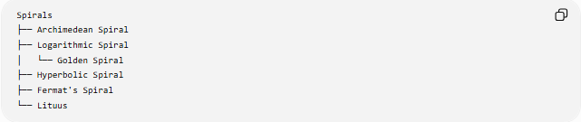
Spirals
├── Archimedean Spiral
├── Logarithmic Spiral
│ └── Golden Spiral
├── Hyperbolic Spiral
├── Fermat's Spiral
└── Lituus
This classification is important because Golden Spiral is a special type of Logarithmic Spiral, rather than a completely independent fundamental spiral family.

Key Points
# Source: AI Source: Provided by: [Data Path: Persons Table -> ID Column: 1, Name_En Column: Motasem Essam] -> From: [ChatGPT] on [7/25/2026]
- A Golden Spiral is a special Logarithmic Spiral.
- It is based on the Golden Ratio:
$$\boxed{ϕ=\frac{1+\sqrt{5}}{2}}$$
- Its radius increases by $ϕ$every ${90}^{∘}$:
$$\boxed{r\left(θ+\frac{π}{2}\right)=ϕr\left(θ\right)}$$
- Its mathematical equation can be written:
$$\boxed{r=ae^{\left(2\ln{ϕ}/π\right)θ}}$$
- It is equiangular.
- Its radial growth is exponential.
- After one complete revolution, the radius increases by:
$$\boxed{ϕ^{4}≈6.854}$$
- Golden Rectangle constructions produce a useful visual approximation, but the exact Golden Spiral is a logarithmic spiral.
- Golden Spiral is a special case of Logarithmic Spiral, not a separate fundamental spiral family.

Conclusion
# Source: AI Source: Provided by: [Data Path: Persons Table -> ID Column: 1, Name_En Column: Motasem Essam] -> From: [ChatGPT] on [7/25/2026]
A Golden Spiral is a specific logarithmic spiral whose radius grows by the Golden Ratio $ϕ$for every quarter turn:
$$\boxed{\frac{r\left(θ+π/2\right)}{r\left(θ\right)}=ϕ}$$
Its exact mathematical form is:
$$\boxed{r=ae^{\left(2\ln{ϕ}/π\right)θ}}$$
It combines the exponential growth and equiangular property of logarithmic spirals with the special geometric ratio of the Golden Ratio. Therefore, in the spiral classification, the Golden Spiral belongs under Logarithmic Spiral.

